Evaluator: Pontus Svensson

Reviewer: Leonardo Iwaya

DATE: 29/03/2024

Task: Perform a number therapy game

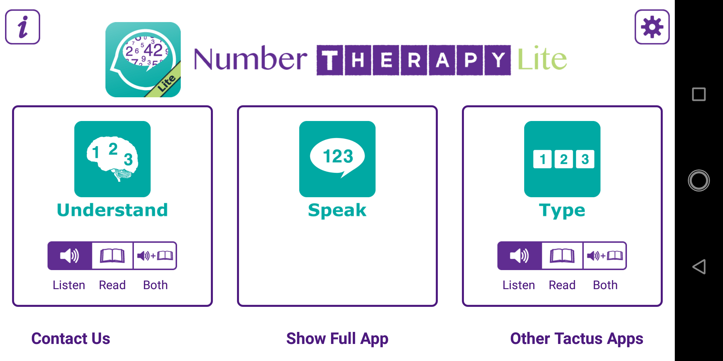

1. In the screenshots seen to the right, the user is performing a game in the app, which is focused on understanding numbers. While inspecting the screenshots to the right, we can see that some text is small. For example, on the second screenshot, there are two boxes, “single” and “multiple,” which enable the user to try a single category or multiple. The text is small and hard to read, which violates the first heuristic **“visibility of system status”**. 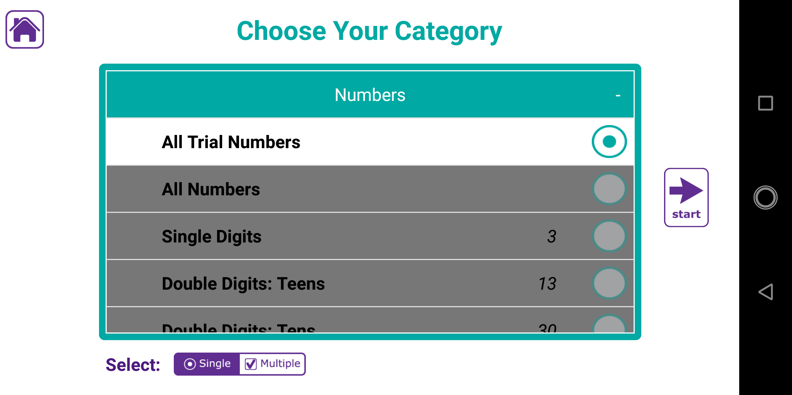

2. The app's various windows indicate its current status, such as the title "Choose your category" seen in the second screenshot. However, during the gameplay section labeled "understand," this clarity is missing. Users may become confused and mistake the section for a different game, such as "speak." This oversight violates the first heuristic, **"Visibility of system status”.**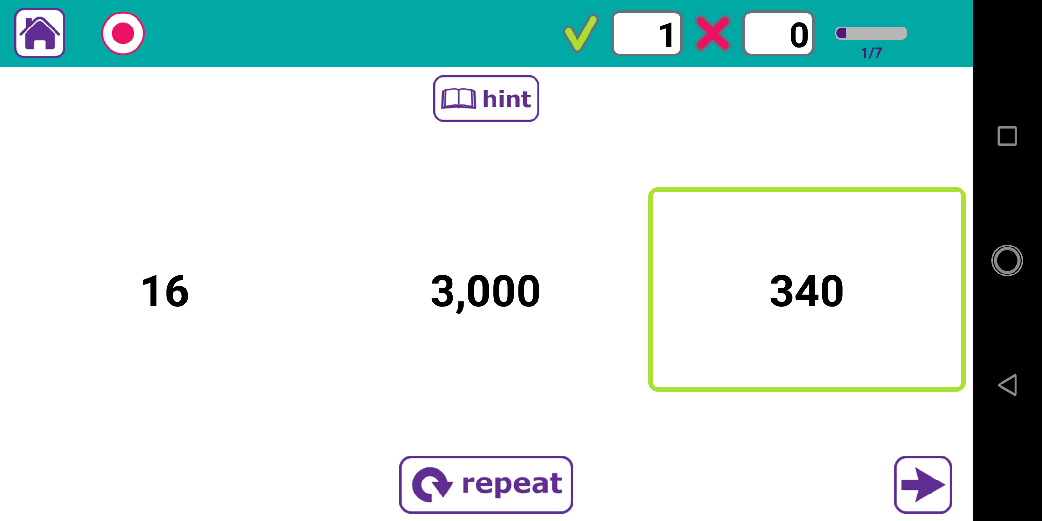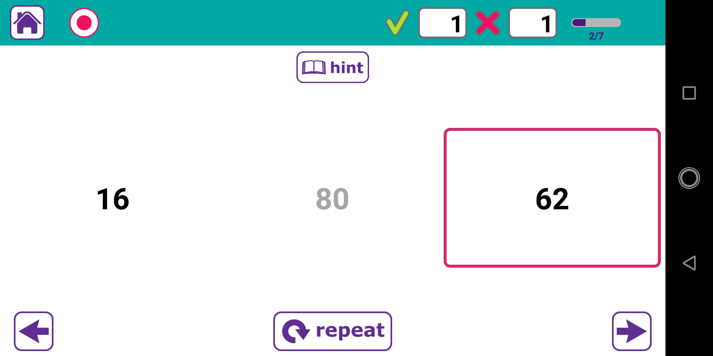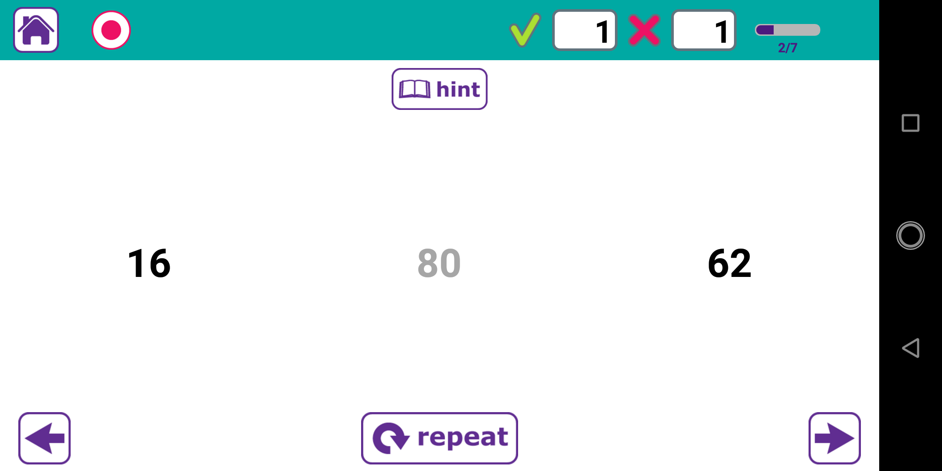

3. To the right, we can see two screenshots from the “speak” game in the app. On the bottom, there are five buttons. These buttons do not specify what they do. This would violate heuristic number six, **“recognition rather than recall,”** as it does not keep important information visible to the user - a small text under the icon could help to explain the buttons’ functionalities quickly.